Prithvi Narayan Campus
Tribhuvan University
Institute of Science & Technology

Internship Report
as
“Backend Developer Intern”
at
Wow Finstack Nepal
In partial fulfillment of the requirements for the Degree of Bachelor of Science in Computer Science and Information Technology

Submitted To:
BSc. CSIT Program
Prithvi Narayan Campus
Submitted By:
Suraj Dhakal (30079/78)

Feb 2026

Tribhuvan University
Institute of Science and Technology
Prithvi Narayan Campus

Supervisor’s Recommendation
I hereby recommend this internship report prepared under my supervision by Suraj Dhakal, a B.Sc. CSIT student at Prithvi Narayan Campus, in partial fulfilment of the requirements for the B.Sc. CSIT degree. During his internship, I observed his consistent dedication and steady progress in all assigned tasks. His work meets the academic and professional standards set by the Institute of Science and Technology at Tribhuvan University.
I confirm that he has satisfactorily completed his internship under my guidance and recommend this report for final evaluation.

Mr. Gyaneshwor Dhungana
Internship Supervisor
B.Sc.CSIT Program

Tribhuvan University
Institute of Science and Technology
Prithvi Narayan Campus

Letter Of Approval
This is to certify that the internship report submitted by Mr. Suraj Dhakal, a student of the Bachelor of Science in Computer Science and Information Technology program at Prithvi Narayan Campus, has been evaluated in accordance with the guidelines of the Institute of Science and Technology, Tribhuvan University, for partial fulfillment of the B.Sc. CSIT degree.
The report meets the required academic and professional standards and is approved for final evaluation.
Mr. Chudamani Subedi  (Program Director)  B.Sc.CSIT | Mr. Gyaneshwor Dhungana  (Internship Supervisor)  B.Sc.CSIT
(Internal Examiner) | (External Examiner)

Declaration
I hereby declare that the internship report entitled “Backend Developer Intern” submitted to the Institute of Science and Technology, Tribhuvan University, in partial fulfillment of the requirements for the degree of Bachelor of Science in Computer Science and Information Technology (B.Sc. CSIT) is a collaborative work undertaken during my internship at Wow Finstack Nepal.
This report has not been submitted to any other institution for the award of any degree or diploma. I have properly acknowledged and cited all the sources of information used in this report in accordance with the APA reference standard.
I further declare that tasks presented in this report are genuine and has been completed during the internship period at Wow Finstack Nepal.

Submitted By:
Suraj Dhakal (30079/78)
B.Sc.CSIT, 2078 Batch
Prithvi Narayan Campus, Pokhara
Acknowledgement
I would like to express my sincere gratitude to each individual whose support and collaboration have made significant differences, either directly or indirectly, in the compilation of this report.
I would like to extend my heartfelt thanks to Wow Finstack Nepal for providing me with the opportunity to gain practical knowledge and real-world industry experience. I am also deeply grateful to my internship mentor Mr. Bishal Devkota for his continuous guidance, support and valuable suggestions throughout the internship period. His professional insights and encouragement greatly helped me in successfully completing my assigned tasks.
I would also like to express my sincere appreciation to my internship supervisor, Mr. Gyaneshwor Dhungana for his constant supervision, feedback and academic guidance during preparation of this report.
In addition, I would also like to thank our CEO, Er. Sujan Tamrakar for his visionary leadership and for fostering a professional environment that encourages learning, innovation, and growth.
Furthermore, I would like to thank all of my colleagues at Wow Finstack Nepal who directly or indirectly supported me during my internship period.

Suraj Dhakal
B.Sc.CSIT 8th Semester
Roll No: 30079/78
Prithvi Narayan Campus

Abstract
This report presents the work undertaken by me during internship at Wow Finstack Nepal, where I worked as a Backend Developer Intern. The primary objective of the internship was to apply theoretical knowledge acquired during the B.Sc. CSIT program to real world software development practices within a professional fintech environment.
During the internship period, I was actively involved in the development and enhancement of backend system for a real world banking system for wow-bank. In this internship, I primarily implemented RESTful APIs using Spring Boot (Java).
The internship allowed me to gain hands-on experience in backend system design, database management, API development and about microservices architecture. Additionally, it enhanced my understanding of financial workflows, transaction processing, account management in banking system. Through this experience, I developed not only technical skills in backend but also some professional skills in problem-solving, teamwork, and communication within a real-world environment.

Keywords: fintech, RESTful API, Java, Spring, Core Banking System, Internet Banking, Mobile Banking
Table of Contents
1. Introduction 1
1.1 Introduction to Internship 1
1.2 Problem Statement 2
1.3 Objectives 3
1.4 Scope and Limitations 3
1.4.1 Scope 3
1.4.2 Limitations 3
1.5 Report Organization 4
2. Organization Details 5
2.1 Introduction to Organization 5
2.1.1 Organization Mission, Vision and Objective 5
2.1.2 Organization Contact Details 6
2.2 Organization Hierarchy 8
2.3 Working Domains of Organization 9
2.4 Description of Intern Department/Unit 10
2.5 Literature Review 11
3. Internship Activities 14
3.1 Roles and Responsibilities 14
3.2 Description of Project Involved During Internship 15
3.3 Weekly Logs 16
3.4 Task/Activities Performed 18
4.1 Conclusion 23
4.2 Learning Outcome 23
References 25

List of Figures
Figure 1: Wow Finstack Logo 6
Figure 2: Organizational Hierarchy 8
Figure 3: Modules of the Organization 10

List of Tables
Table 2.1 Internship Durations 11

Table 3.1 Weekly Logs 15

List of Abbreviations
API | Application Programming Interface
CBS | Core Banking System
CMS | Card Management System
JSON | JavaScript Object Notation
JWT | JSON Web Token
NPT | Nepal Time Zone
ORM | Object Relational Mapping
REST | Representative State Transfer

1. Introduction

1.1 Introduction to Internship
An internship is an opportunity to integrate career related experience into an undergraduate education by participating in planned, supervised work. It helps in personal and professional development through meaningful tasks; it is typically done before graduation to gain proper real-world environment (Definition of Internship (as set forth in the Ohio State University Department of Political Science), 2013).
Internships exist in a wide variety of industries and settings. An internship can be paid, unpaid, or partially paid (in the form of a stipend) Internships may be part-time or full-time and are usually flexible with students' schedules (Unpaid internships face legal, ethical scrutiny, 2012). A typical internship lasts from 1-4 months generally but can be longer or shorter according to the organizations. The act of job shadowing may also constitute interning. (Job Shadow, 2013)
Internships can be of various duration ranging from weeks to several monsths and can be full-time or part-time. They may be paid or unpaid. The objectives of an internship also vary according to organizations and fields. Some internships focus on providing general exposure to a particular industry. Others provide some specific learnings, such as developing technical skills, or giving contribution to a specific project.
During my Internship at Wow Finstack Nepal, I worked as backend developer intern on the development of WOW-bank, a complete digital banking system. This project involved building CBS, Internet Banking, and Mobile-Banking applications. This internship provided me an opportunity to apply theoretical knowledge gained from B.Sc. CSIT program in real world environment. My work included designing and implementing backend services using Spring Boot (Java), managing databases, developing RESTful APIs and working with authentication.
The goal of the internship at Wow Finstack Nepal will be to develop, deliver, and maintain comprehensive transactional banking solution with tried and tested technologies.

1.2 Problem Statement
The Wow Digital Banking Platform, developed with support from Wow Finstack, serves as a modern solution for cross-border financial services particularly salary collection, remittances, card management, and everyday banking for users like migrant workers in Israel and beyond.
Although academic coursework provides strong theoretical foundations in programming, database management, and system design, it does not fully prepare students to handle the real-time, large-scale, and security-critical demands of a live fintech production environment. The current core banking system (CBS) supporting the platform reveals several practical challenges that highlight the gap between classroom learning and industry-level system implementation.
Several problems that are holding back the project are:
- No presence of caching and using memory for everything degrades the performance of the slow processing speed.
- Outdated workflows and unoptimized processes drag performance, especially during busy periods when the system struggles to keep up.
- Many features remain underutilized because the interface and capabilities feel clunky and outdated, making it harder for users and operations teams to get the most out of the platform.
- Security measures are not robust enough to fully safeguard sensitive financial data, leaving potential vulnerabilities that could be exploited through common penetration testing tools or attacks.
- Integration with new modules or third-party services is very limited, which makes it difficult to quickly add or expand digital banking features as the business grows.
- Reliance on older technology including legacy code and many deprecated libraries prevents adoption of modern capabilities like real-time transaction processing, advanced payment options, and seamless scalability.
These challenges together create bottlenecks in reliability, user experience, security, and the ability to innovate and scale the platform effectively. Addressing them through targeted backend improvements (such as modernizing APIs, strengthening security layers, optimizing performance, and enabling better integrations) is essential to make the Banking platform more responsive, secure, and aligned with the needs of a competitive digital banking environment.

1.3 Objectives
The main objective of this internship is to gain practical experience and skills in a real-world environment and develop professional networks and industry insights to enhance career prospects. The specific objectives of internship project are:
- To gain practical experience in backend development and working with RESTful APIs.
- To apply theoretical knowledge learned during the B.Sc. CSIT program in real world professional environment about different data structures and algorithms.
- To develop professional skills such as teamwork, communication, time management, architecture design, and problem-solving.
- To get insights about industry standards for how Java and Spring framework are used in secure fintech environment in real world

1.4 Scope and Limitations

1.4.1 Scope
The internship at Wow Finstack Nepal involves good learning experience in backend development and digital banking. The scope includes:
- Working with Spring Boot and Java to design, implement and test backend services.
- Learning and applying Microservices architecture for modular, scalable banking systems.
- Gaining hands-on experience in backend development for enterprise fintech applications.

1.4.2 Limitations
Despite the extensive learning opportunities, the internship also has some limitations. Some of the limitations are:
- The limited duration of the internship doesn’t let us learn the in-depth concepts and also limits the ability to explore additional projects.
- There was language barrier with the clients as most of them were from Israel and Russia and communication in English was challenging some times.
- As intern, scope for making independent decisions were also limited with the major decisions requiring consultance with and approval from the mentor
- The complete banking system is huge which cannot be learned in limited internship period.

1.5 Report Organization
Chapter 1 consists of Introduction to Internship, what is the problem statement for the internship and what are the major objectives, scope and limitations of the internship and also provide overview of the report’s content and what will be covered in other chapters.

Chapter 2 includes the information about the organization, its scope and objectives, its contact details and how the hierarchy of the organization is maintained, It also shows the working domains of the organizations and the department where I worked.

Chapter 3 outlines roles and responsibilities that I carried during the internship period, Weekly log of the task I performed, Description of the Project involved during internship, description of the task and activities that is performed by me during internships. It also includes what tools, platforms have been used in the organization for development of projects

Chapter 4 summarizes the internship experience, project achievements, and the technical and professional skills acquired during the internship. It concludes the whole report with what I learned from this experience.

2. Organization Details

2.1 Introduction to Organization
Wow Finstack is a fintech company that develops a complete, modular technology stack designed for banks, fintech companies, and small-to-medium enterprises (SMEs). The platform provides all the essential components needed for payments and transactional banking from customer and merchant onboarding, issuing physical or virtual cards (debit, credit, or wallet), merchant acquiring, payment gateway services, to the backend processing that supports everything. All features are fully configurable through simple, well-documented APIs. (Wow Finstack Nepal, 2026)
The system is built with a strong focus on security, regulatory compliance, scalability, and reliability. The main idea is to allow businesses to concentrate on serving their customers while WOW Finstack handles the complex technical and compliance requirements in the background.
Although the company is headquartered in Singapore, its solutions are used by clients across multiple countries, helping banks, fintechs, and merchants launch and grow their digital financial services effectively.

2.1.1 Organization Mission, Vision and Objective
      - Mission: Wow Finstack exists to change the way businesses especially banks, fintech companies, and SMEs use modern payment and banking technology. Instead of struggling with complicated systems, They give them a modular and scalable tech stack that fits their needs.
The platform is flexible, easy to configure, and built to help companies launch financial services faster, integrate everything smoothly, and stay compliant without the usual headache. Simply put, They provide the tools that let businesses build reliable financial products with confidence and speed.
      - Vision: To become the trusted backbone of digital finance around the world. Whether it’s a small shop or a big enterprise, any business should be able to offer top-class banking and payment services without all the complexity.
Their goal is to make financial technology simple and accessible everywhere, removing the barriers that stop businesses from growing and adopting modern digital finance.

- Objective:
- To build and maintain an innovative, enterprise-grade fintech stack that covers everything from onboarding and card issuance to merchant acquiring, payment gateways, fraud checks, and compliance.
- To offer modular solutions so clients can choose exactly what they need. This helps them launch faster and cut costs compared to building everything from scratch.
- To support global expansion, making it easy for clients in different countries to launch and manage payment services with as little friction as possible.
- To provide flexible deployment options whether hosted or self-hosted along with fully configurable APIs. This allows businesses of all sizes, from new fintech startups to long-established banks, to customize the platform to their unique needs.

2.1.2 Organization Contact Details
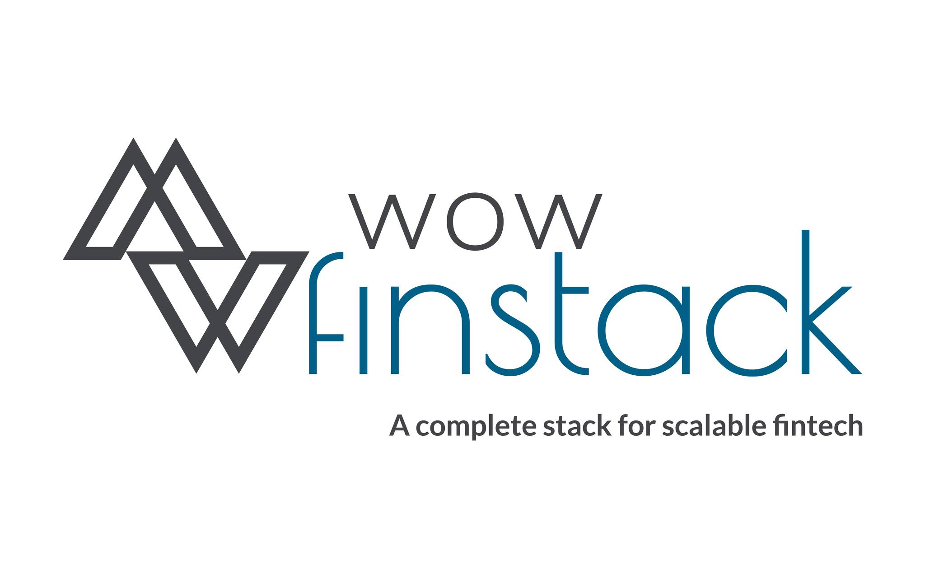
Figure 1: Wow Finstack Logo

Wow Finstack Nepal Pvt. Ltd
Nayabazar, Pokhara, Nepal
Phone: +977-9849852882
Email: info@wowfinstacknepal.com
Website: www.wowfinstacknepal.com
Opening Time: 10 am – 6 pm NPT
Social Media / Professional Links:
Facebook: https://www.facebook.com/wowfinstacknepal
LinkedIn: https://np.linkedin.com/company/wowfinstacknepal
For the parent/global entity (WOW Finstack):
Website: https://wowfinstack.com/
Contact Page: https://wowfinstack.com/contact-us (features a form for inquiries, no direct phone/email publicly listed on the main site).

2.2 Organization Hierarchy
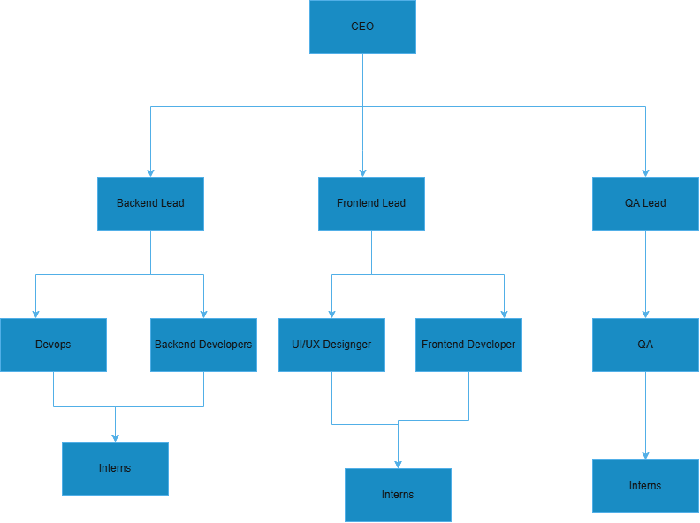
Figure 2: Organizational Hierarchy
Wow Finstack Nepal is led by a strong top-level management team that sets the company’s vision and strategy. Under their guidance, the Project and Product Management team oversees all development work and keeps projects aligned.
The Development Department is organized into several specialized teams:
- Frontend Team: Builds the user interface and ensures the application is responsive and easy to use.
- Backend Team: Handles server-side logic, databases, APIs, security, and the core business processes.
- Design / UI-UX Team: Works on user experience and interface design, and collaborates with the frontend team to bring the designs to life.
- Quality Assurance (QA): Tests the system to make sure everything is reliable and performs well
- DevOps / Infrastructure: Manages deployments, servers, monitoring, security, and overall system stability.

2.3 Working Domains of Organization
Wow Finstack Nepal operates primarily in the fintech and digital financial services sector. This organization specializes in providing a complete, modular and enterprise-ready technology stack for the traditional banks, digital banks, fintech companies, and small-to-medium enterprises(SMEs). (Wow Finstack Nepal, 2026)
Key working domains for this organization includes:
- Core Banking System
- Card Management and Issuing
- Payment Gateway Services
- Internet Banking
- Acquirer Systems
- Notification Services
- Remittance Services
- Compliance, Security, and Scalability
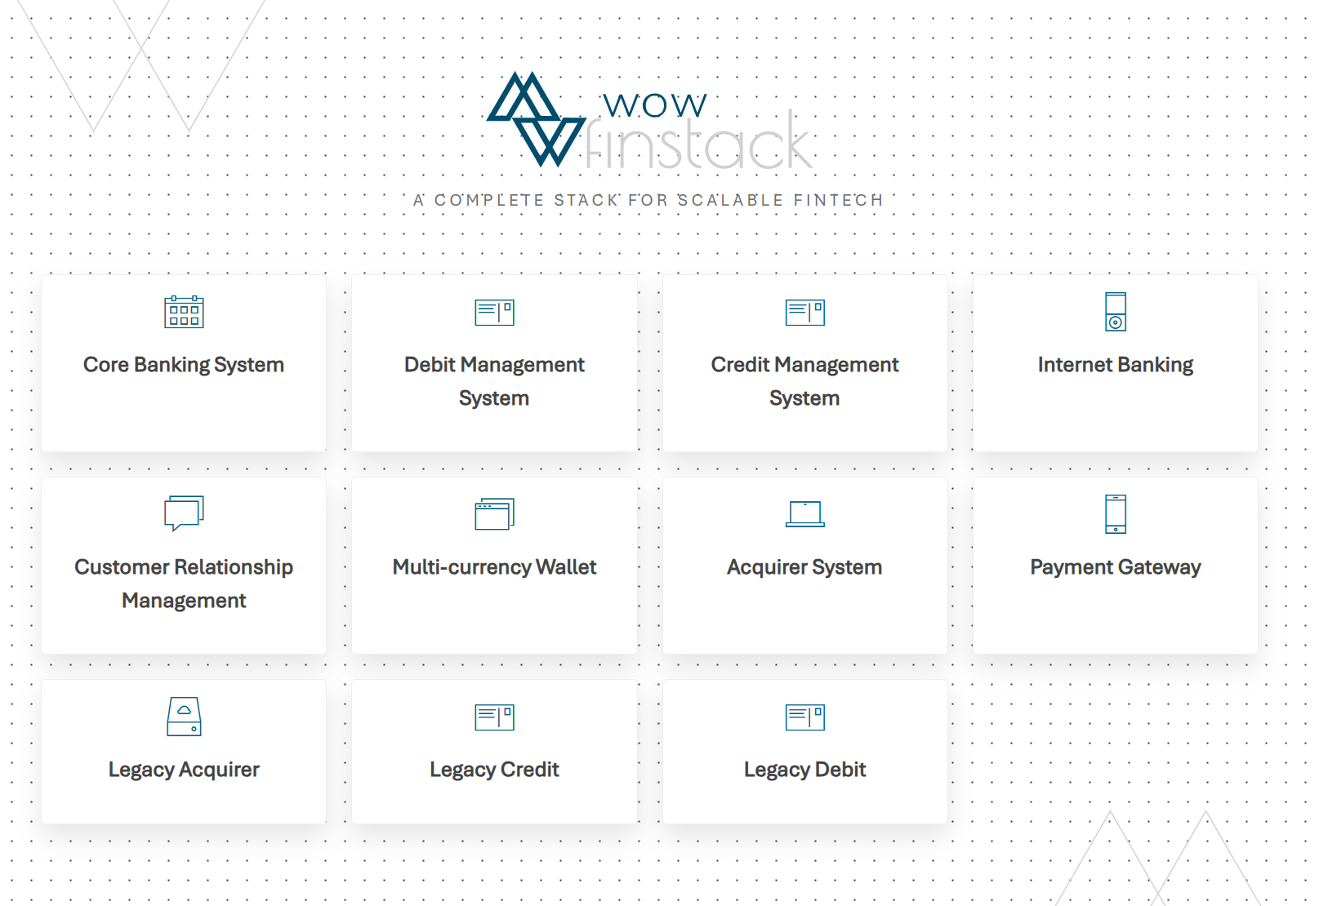
Figure 3: Modules of the Organization

2.4 Description of Intern Department/Unit
During this internship, my placement was in the Backend Development Team at WOW Finstack Nepal Pvt. Ltd. This unit forms a critical part of the company's technology development operations in Pokhara, focusing on building and maintaining the server-side components of the modular enterprise-grade fintech platform used by clients globally.
The Backend Development Unit is responsible for the core technical implementation of WOW Finstack's payment and transactional banking solutions. It handles the design, development, testing, and optimization of backend services that power features such as secure APIs, transaction processing, data management, integrations, authentication and security mechanisms. The team works closely with other units like frontend, DevOps and QA to deliver scalable and high-performance solutions.

Key responsibilities and activities of the unit include:
- Developing RESTful APIs and microservices to support modular components like customer/merchant onboarding, card issuing, payment acquiring, remittances, and wallet management.
- Implementing business logic for real-time transactional processing.
- Ensuring security through mechanisms such as authentication (e.g., JWT), encryption, fraud detection, and compliance with standards (e.g., AML checks, KYC Verification).
- Interacting with databases (PostgreSQL and MySQL) using frameworks for efficient data access and querying.
- Integrating with external systems, partners, and third-party services (e.g., banks, payment gateways, Digital Signature Providers) to enable seameless operations.
- Optimizing performance for scalability, reliability under load, and minimal latency essential for fintech applications serving multiple countries and users.
- Collaborating on code reviews, version control (Git), automated testing, and deployment processes to maintain code quality and rapid iteration.

Table 2.1 Internship Durations
Start Date | 2 November, 2025
Internship Duration | 2.5 months
Office Hours | 10 am – 6 pm
Working Days | 5 days a week
Working Hours | 8 hours a day
Mentor | Mr. Bishal Devkota

2.5 Literature Review
For banking system like wow bank to build a secure and scalable API in digital banking, Spring Boot is considered as the primary framework for backend development It also touches on broader fintech challenges in secure transactional systems and remittances, contextualized with Nepal's digital banking landscape where applicable.
Spring Boot has proven itself a good backend framework in enterprise and fintech environments due to its ability to simplify the creation of production-ready applications. It provides auto-configuration, embed servers, and strong support for modular architecture, RESTful APIs, and security features (Spring Boot documentation., 2026) . In fintech, Spring Boot allows fast development of secure payment processing systems, with many built-in features for security with features like Spring Security for proper authentication and authorization and scalability through modular architecture. Many Studies and Real World Implementation also highlight Spring boot is used in banking applications for features like user authentication (JWT-based), transaction handling, fund transfers, and following standards like PCI DSS (Oceanobe. (2025). Secure payment processing with Java modules and Spring Boot., n.d.). For instance, microservices-based banking systems built with Spring Boot and Spring Cloud address scalability, fault tolerance, and independent service deployment critical for high-volume transactional platforms (The American Journals. (2025). Application of Spring Boot microservice architecture for scaling banking applications., n.d.)

In the context of cross-border remittances and digital-banking, secure backend development might have challenges like real-time processing, encryption, fraud detection, AML compliance, and integration with different financial systems (payments., Evincedev. (2016). Money transfer app development guide for secure global, n.d.).
In Nepal's fintech ecosystem, digital banking adoption is growing but constrained by infrastructure gaps, digital literacy issues, regulatory hurdles, and cybersecurity concerns (Dhakal, P., & Acharya, M.. (2025). The impact of digital transformation on banking services and customer experience: A study of the Nepalese banking sector. Theseus., n.d.). Fintech innovations are helping close long-standing gaps in financial access by making services like mobile remittances faster and more inclusive. There are still some big challenges out there, like in rural spots where getting internet is tough and people might not know much about digital stuff. It feels like that makes things harder overall.

WOW Finstack's modular, API-driven platform aligns well with global fintech trends by providing compliant, scalable solutions that enable clients in developing markets to adopt cross-border capabilities without building from scratch. The literature reinforces Spring Boot's suitability for fintech backends, it accelerates development while embedding security, scalability, and maintainability directly supporting the enhancements made during the internship, such as improved APIs for transactions and authentication on the WOW-bank platform.

When you look at the literature, it really points out how Spring Boot works so well for backends in fintech. It speeds things up in development, and it has security, scalability, and ways to keep it maintainable right from the start. It has many built-in features
This ties back to what I did in the internship, especially working on APIs for handling transactions and making authentication better on the WOW platform. The research backs up how relevant all that tech was in real situations during the experience. Not everything is perfect, but it shows the impact pretty clearly. Some parts of the internship felt messy, like figuring out those enhancements, but it made sense in the end.

3. Internship Activities

3.1 Roles and Responsibilities
As a Backend Developer Intern at WOW Finstack Nepal, I worked directly on the WOW-bank Digital Banking Platform under the guidance of my mentor Mr. Bishal Devkota and alongside the backend team.
My main job was to help build and improve the server-side parts of the system using Java and Spring Boot. I took part in the full development process from getting tasks assigned, writing code, testing it, fixing bugs, and making sure everything worked smoothly with the rest of the platform.
Here are the key things I was responsible for during the internship:
- Building and improving RESTful APIs for important features like secure transactions, user login, fund transfers, adding new transaction types, provide notifications
- Helping create secure authentication and authorization using JWT so only authorized users could access sensitive endpoints.
- Working with the database to handle data properly performing CRUD operations for things like user profiles, transaction history, audit logs and transaction settlement.
- Writing clean, efficient code and optimizing parts that needed better performance, especially for handling multiple requests at the same time.
- Fixing bugs that came up during development or testing, and making sure the fixes didn’t break anything else.
- Writing basic unit and integration tests to check that the new code worked correctly.
- Joining daily team meetings, sprint planning, and code review sessions to discuss progress and get feedback on my work.
- Using Git for version control, committing changes regularly, and pulling updates from the team. We used trunk-based git branching.
- Learning how to integrate backend services with external systems, like payment gateways or partner banks, while keeping everything secure and compliant.
Most of my tasks started simple (like small bug fixes and learning the codebase) and gradually became more challenging as I got more comfortable. I always tried to follow best practices for clean code, security in fintech applications, and writing readable, maintainable code.
Through these responsibilities, I got real experience working on live international project and learned a lot about how the backend development actually happens in professional fintech company.

3.2 Description of Project Involved During Internship
As an intern at Wow Finstack Nepal, I contributed to the backend development of the WOW Core Banking System (CBS), which is built using the Spring Boot framework. My responsibilities include assisting in the development, customization, and maintenance of the CBS backend, enhancing system structure and performance, and implementing new features that support smooth and efficient core banking operations.
I also was involved in strengthening security measures within backend services as the data related to banking system are sensitive and requires proper user trust. In addition, I supported optimization tasks to ensure that CBS components built with Java and Spring Boot operate reliably and handle banking workloads effectively.

Another key part of my role involves assisting with the integration of advanced transaction processing features, enabling secure and seamless execution of activities such as fund transfers, account management, encryption/decryption of the data and other essential banking functions through the CBS. I also worked on the notifications service that sends the messages related to the banking through kafka in sms or email.

This project gave me the opportunity to work with industry standard Java Backend Code and real-world banking systems.By contributing to the internship for this project, I aim to enhance its functionality and overall system performance and support financial institution providing secure, scalable and efficient digital banking services.

3.3 Weekly Logs
The weekly log documents the progress of internship activities over an eight-week period. It outlines responsibilities assigned, tasks performed, observations made, and plans for subsequent weeks, reflecting continuous learning and professional development throughout the internship.
Table 3.1 Weekly Logs
Week | Responsibilities | Activities Performed | Observations
1 | Onboarding and understanding company processes | Completed onboarding, set up dev environment (JDK, IntelliJ, DB), learned trunk-based Git and microservices basics | Microservices enable independent team work; fintech decisions impact real money and trust
2 | Access and understand WOW-bank codebase | Cloned repo, explored project modules, studied database schema and Liquibase migrations | Liquibase ensures safe DB versioning; strict standards reduce bugs in fintech
3 | Research and implement JWT authentication | Studied JWT (access/refresh tokens), implemented JWT util with jjwt, tested login → token → protected APIs | JWT is stateless and scalable for microservices; proper handling prevents misuse
4 | Add card transaction types and APIs | Added ATM/POS/SALE transactions, implemented balance updates and history logging, tested consistency across microservices | Concurrency handling and logging are crucial for auditing in banking
5 | Implement notification microservice with Kafka | Studied Spring Kafka, added topics (card tx, failed login), built template-based SMS/email workflow | Kafka enables async, reliable notifications; DB templates allow easy updates
6 | Implement change password/phone/email APIs | Added old password validation for change-password, synced updates across microservices, handled edge cases | Encrypted storage and old password check boost security; sync prevents inconsistencies
7 | Research fingerprint/biometric login for mobile app | Studied biometric flows (Android/iOS APIs, zero-knowledge), designed rough architecture and DB schema | No raw biometrics stored centrally; challenge-response ensures privacy and compliance
8 | Implement biometric authentication backend | Built register-device, challenge generation/verification endpoints, stored device keys/public keys | Biometric is user-friendly and secure with device-bound proofs; good integration with Spring Security
9 | Learn and practice unit testing in Spring Boot | Studied JUnit 5 + Mockito, wrote tests for services/controllers (e.g., auth, transactions) | Mockito isolates units effectively tests improve confidence in refactoring
10 | Implement ComSign digital signature for onboarding | Researched ComSign Swagger API, integrated signature in account opening form, handled upload/sign/callback | ComSign provides compliant e-signatures; adds non-repudiation for fintech onboarding

3.4 Task/Activities Performed
During my internship in Wow Finstack Nepal, I have performed many tasks that contributed to building of the WOW Banking Application. I have worked on various microservices architectures to make the WOW-bank system reliable and solid.
The List of tasks performed by me are:
3.4.1. JWT Authentication:
This was one of the first task I performed in earliest phase of my internship. I achieved this using Spring Security and Some external libraries that supported jwt authentication. I replaced the traditional single username password-based authentication with the jwt token base authentication.
Core Technologies and dependencies used for this are:
          - JJWT: gradle library for jwt creation, validation and parsing
          - Spring Security: built in filter based authorization framework
          - JPA/Hibernate : used for database storage of the refresh token
Key Dependencies used:
          - jjwt-api
          - jjwt-impl
          - jjwt-jackson
          - spring-security
I created JWT utility for the authentication including methods:
generateJwtToken(): Creates access tokens with 15-60 min expiry
generateJwtRefreshToken(): Creates refresh tokens with extended validity (7-30 days)
validateJwtToken(): Validates token signature, expiration, and claims
validateAndGetAuthentication(): Converts valid JWT into Spring Security Authentication object
getTokenVersionFromJwtToken(): Retrieves token version for invalidation support

I created a filter for JWT , filter is required concept in Spring Security
JWT Authentication Filter
          - Custom servlet filter for request interception:
          - Extracts JWT from Authorization: Bearer <token> header
          - Multi-tenant support with tenant identifier validation
          - Token version verification (prevents use of revoked tokens)
          - System user bypass logic (public, internal users)
Exception handling with user-friendly error responses:
- ExpiredJwtException → "Token expired"
- SignatureException → "Invalid signature"
- MalformedJwtException → "Malformed token"
- BadCredentialsException → "Old token version"
Flow for JWT Authentication was Given as:
1. Client → POST /authentication {username, password}
2. Server → Validate credentials via DaoAuthenticationProvider
3. Server → Increment user.tokenVersion
4. Server → Generate Access Token (15min) + Refresh Token (7d)
5. Server → Store refresh token in DB
6. Server → Return {accessToken, refreshToken, userId, roles, permissions}
7. Client → Use accessToken in Authorization header for API calls
8. On expiry → POST /refresh-token {refreshToken}
9. Server → Validate refresh token → Issue new token pair

    - Add new Transaction Types for Card Related Transaction
I also worked on Savings Account part where I added the transaction related to cards like ATM Transaction, POS and ECOM.

Primary Card Transactions Implemented are:
- ATM_TRANSACTION - Cash withdrawals at ATMs
- POS - Point of Sale transactions
- ECOM - E-commerce/online purchases
I have created various methods in this system. For each of these card transactions I created method so that it would update the database with the new amounts that is remaining (aka runningBalance) after the transaction. I have created enum for these transaction types so that it can be validated from the transaction type enum which kind of transactions is performed and provide proper audit logs and balance and transaction history to the users.

3.4.3 Notification Services
During Internship, I also worked on notification microservice which was made for sending Email and SMS to the customers of the banking system or to notify admins or CDD officer about system alerts. I have added some topics for these notifications such as message for transactions, user login failed attempt alert,etc.
The notification Service is being implemented using Spring Kafka Framework to consume messages from the kafka topics and process them for sending notifications.

Kafka listeners consume messages from different topics (Transaction, Account, etc.)
Messages are received as KafkaEvent objects containing:
- Topic name
- Event data
- Additional metadata

Template Retrieving method created in the service retrieves predefined templates based on topic
Templates are stored in database via Jpa Repository (ORM for Spring Boot)
A method is created which expands the Dynamic Placeholder from the template and put the value coming in the json response.
Switch-case logic handles different topics (Transaction, Account, etc.)

The Complete Workflow for Notification Service is:
- Kafka producer publishes events to specific topics
- Consumer listens to configured topics using @KafkaListener
- Event is received and parsed
- Corresponding SMS template is fetched from database
- Template placeholders are replaced with actual event data
- Final message is generated and sent via SMS service
    - Biometric Authentication
I also implemented Biometric Login for the mobile app users for WOW-bank Plus Application which is a mobile banking app. Fingerprint authentication is provided for convenience of the user so that they can login faster.
Implementation Workflow
1. Device Registration Phase
- User initiates device registration through the mobile application
- System validates user credentials and device information
- Public key from the user's device is securely stored in the database
- Device fingerprint is generated and associated with the user account
- Only one active biometric-enabled device is allowed per user
2. Challenge-Response Authentication Flow
- User requests biometric login from their registered device
- System generates a unique cryptographic challenge (nonce)
- Challenge is temporarily stored and associated with the user session
- Mobile application signs the challenge using the device's private key
- Signed response is sent back to the server for verification
3. Signature Verification & Authorization
- Server retrieves the stored public key for the device
- Cryptographic signature is validated against the challenge
- Device fingerprint is verified to ensure request originates from registered device
- Upon successful verification, authentication tokens are generated
- User is granted access to the application
4. Device Management
- Users can disable biometric authentication for their device
- System maintains audit logs for all biometric-related operations
- Previously enabled devices are automatically disabled when new device is registered
- Device status (enabled/disabled) is tracked in the database.
3.4.5. Digital Signature
ComSign is a third-party digital signature service integrated to enable secure electronic signing of customer onboarding documents, particularly account opening forms. This integration helps streamline the onboarding process by eliminating physical paperwork and enabling fully digital document execution.
Authentication & Secure Access
- Establishes secure communication with the ComSign service using token-based authentication.
Document Preparation & Template Management
- Generates onboarding documents in PDF format programmatically.
- Uploads documents to ComSign for digital signing.
- Configures signature placement dynamically within the document.
Signature Workflow Automation
- Initiates document signing requests for customers.
- Sends automated email notifications with secure signing links.
- Enables customers to review and electronically sign documents online.
Document Retrieval & Secure Storage
- Downloads completed signed documents.
- Securely stores finalized documents in cloud storage.
- Updates the onboarding process based on signing completion.
Webhook Integration
- Implements automated callbacks to receive real-time signing updates.
- Triggers backend processes once documents are signed or failed or rejected.
4. Conclusion and Learning Outcomes

4.1 Conclusion
This internship at WOW Finstack Nepal as a Backend Developer Intern gave me the chance to work on a real, live international fintech project the WOW Digital Banking Platform for an Israeli client. Over the past weeks, I contributed to improving the backend using Java and Spring Boot, focusing on making APIs more secure, reliable, and efficient for features like everyday transactions, user management and authentication,etc.
The experience showed me firsthand how challenging but rewarding it is to build backend systems for digital banking. We tackled real issues like slow processing from legacy code, security gaps, limited integrations, and the need for better scalability to handle real user loads. Even though the internship was short, the work I did building and fixing APIs, adding authentication layers, optimizing database calls, and learning secure coding practices helped move the platform a step closer to being more responsive and trustworthy for users, many of whom are migrant workers relying on it to manage their hard-earned money and send funds home safely.
Overall, the internship met its main goal i.e. bridging what I learned in college with actual industry work. It confirmed that fintech demands not just technical skills but also attention to security, performance under pressure, teamwork in agile setups, and understanding user needs in a global context. I'm grateful for the opportunity to contribute to something meaningful that impacts real people's financial lives.

4.2 Learning Outcome
Through this hands-on experience, I gained several important skills and insights:
- Technical Growth: I became much more confident with Spring Boot and Java for building production-ready RESTful APIs, handling authentication (JWT), database operations with Spring Data JPA, and writing cleaner, more efficient code. I also learned practical debugging, testing, and optimization techniques that aren't always covered deeply in classes. I also learned about Kafka and how event driven system works.
- Fintech-Specific Knowledge: I understood better how backend systems support secure cross-border payments, remittances, card issuing, and compliance in a regulated environment. Seeing how legacy issues affect performance and how modernizing parts can make a big difference was eye-opening.
- Professional Skills: Working in a real team taught me agile practices daily stand-ups, code reviews, Git workflows, and communicating progress clearly. I learned to take feedback seriously, document my work properly, and manage tasks under deadlines.
- Soft Skills and Mindset: The internship made me more pragmatic and professional. I realized the importance of writing secure, maintainable code in fintech (where mistakes can have real consequences), collaborating across time zones or teams, and thinking about end-users (like migrant workers needing simple, reliable tools).
- Personal Development: It boosted my confidence in contributing to live projects and showed me I'm capable of handling real-world challenges. It also motivated me to keep learning about modern backend tools, cloud deployments, and advanced security in finance.
In short, this internship transformed theoretical knowledge into practical ability and prepared me better for a career in software development, especially in fintech. I'm excited to apply these lessons in future roles and continue growing in this dynamic field.

References
Definition of Internship (as set forth in the Ohio State University Department of Political Science). (2013, Janurary 22). Retrieved from https://polisci.osu.edu/sites/polisci.osu.edu/files/What%20is%20an%20Internship.pdf

Dhakal, P., & Acharya, M.. (2025). The impact of digital transformation on banking services and customer experience: A study of the Nepalese banking sector. Theseus. (n.d.). Retrieved from https://www.theseus.fi/bitstream/handle/10024/885781/Dhakal_Acharya.pdf

Job Shadow. (2013). Retrieved 11 30, 2017, from https://www.fvhca.org/job-shadow.html
Oceanobe. (2025). Secure payment processing with Java modules and Spring Boot. (n.d.). Retrieved from https://oceanobe.com/news/secure-payment-processing-with-java-modules-and-spring-boot/1613

payments., Evincedev. (2016). Money transfer app development guide for secure global. (n.d.). Retrieved from https://evincedev.com/blog/money-transfer-app-development-guide/

Secure Payment Processing with Java Modules and Spring Boot. (2025). Retrieved from https://oceanobe.com/news/secure-payment-processing-with-java-modules-and-spring-boot/1613

Spring Boot documentation. (2026). Retrieved from https://spring.io/projects/spring-boot

Spring.io. (2026). Retrieved from Spring Boot documentation.: https://spring.io/projects/spring-boot

The American Journals. (2025). Application of Spring Boot microservice architecture for scaling banking applications. (n.d.). Retrieved from https://www.theamericanjournals.com/index.php/tajet/article/view/6673
Unpaid internships face legal, ethical scrutiny. (2012). Retrieved April 30, 2004, from https://web.archive.org/web/20120406084519/http://orient.bowdoin.edu/orient/article.php?date=2004-04-30&section=3&id=1

Wow Finstack Nepal. (2026). Retrieved 11 30, 2025, from https://wowfinstacknepal.com/

APPENDICES
- Git repo for Microservices
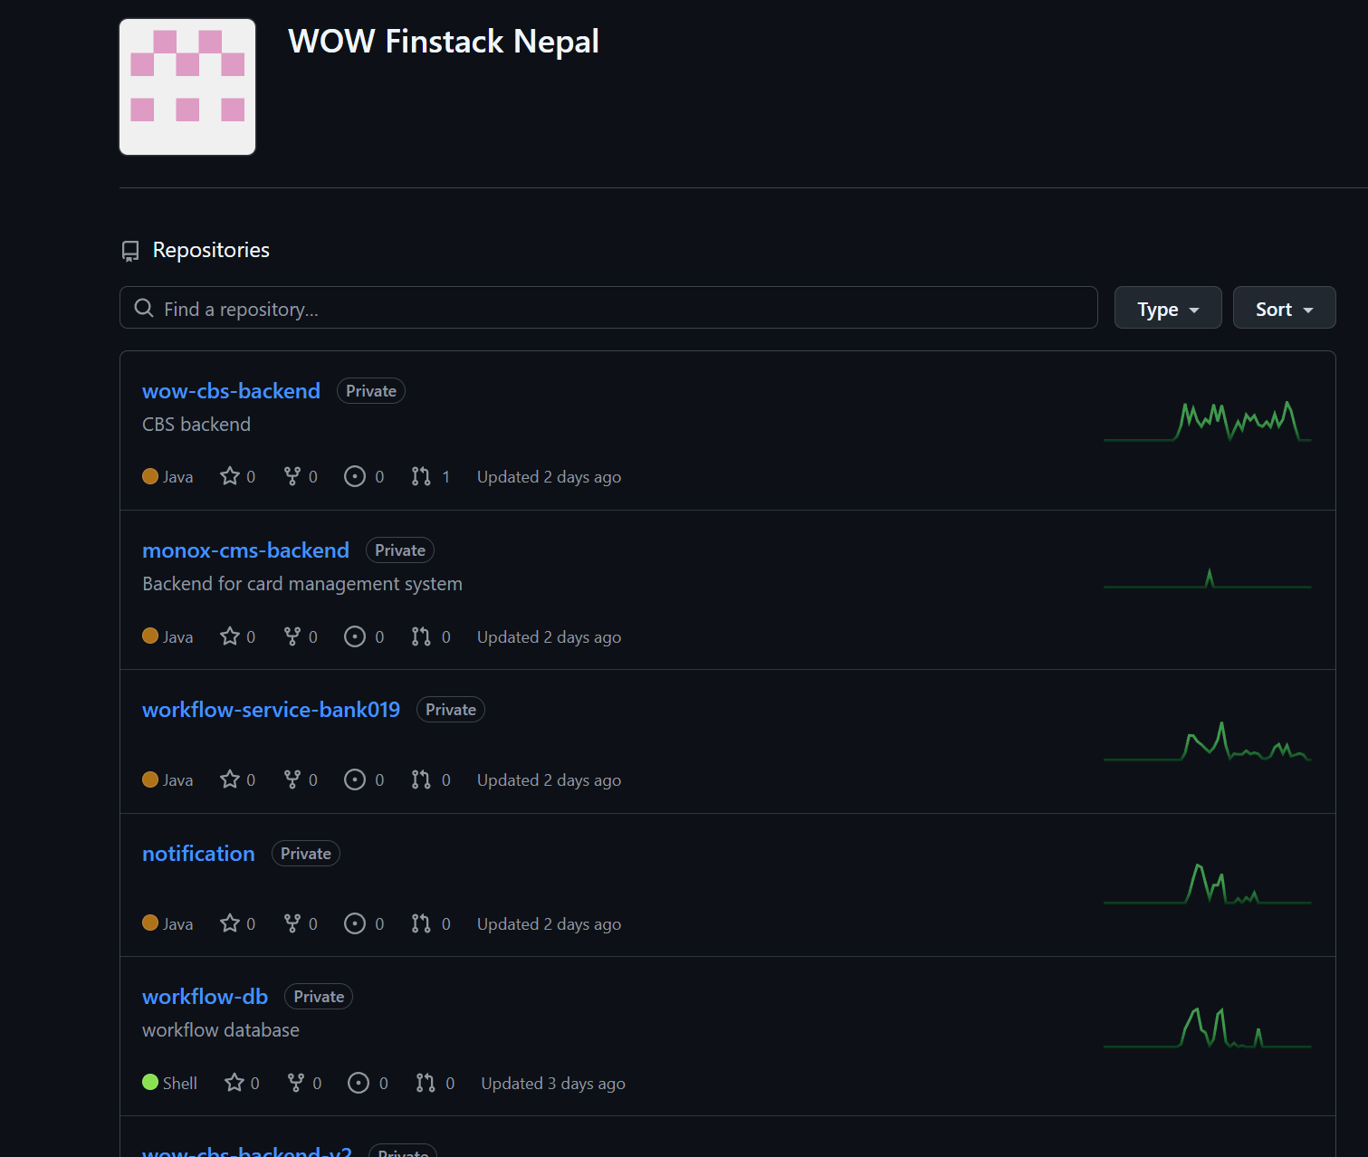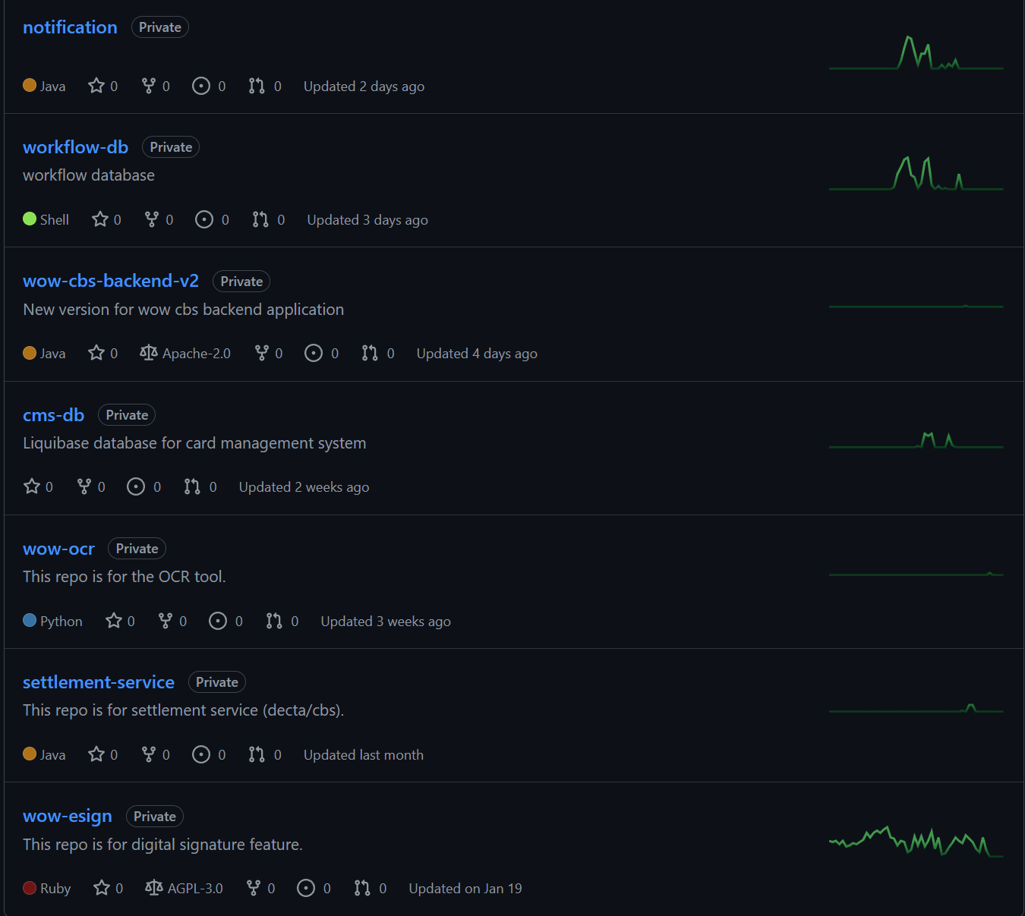

- My Contributions
